Why You Need to Rethink Your Data and Analytics Roles Now

[[Share this on Facebook](https://www.gartner.com/doc/3389917?srcId=1-6470977776)](https://www.gartner.com/doc/3389917?srcId=1-6470977776)[Tweet](https://twitter.com/share)[in](javascript:void(0);)

https://www.gartner.com/imagesrv/apps/gproduct/images/reader/icon-archive.png;wa2252afb7081fbffd ARCHIVED **Published:** 26 July 2016 **ID:** G00308242

**Analyst(s):** [Thomas W. Oestreich](http://www.gartner.com/analyst/48682)| [Frank Buytendijk](http://www.gartner.com/analyst/17247)

Summary

Data and analytics has become strategic; it is almost omnipresent throughout organizations and needs to be ready for algorithmic business. Data and analytics leaders must address changing roles to clarify responsibilities, the business-IT partnership and, ultimately, business impact.

Overview

Impacts

* The increased strategic importance of data and analytics calls for the creation of an executive-level data and analytics leader.
* The omnipresent decentralization of data and analytics use cases leads to many part-time and hybrid roles across lines of business, including IT, increasing business complexity.
* The trend toward algorithmic business will create new responsibilities and roles for those managing data and analytics.

Recommendations

Data and analytics leaders must:

* Make the business case for the chief data officer.
* Engage with key players in data and analytics use cases within the organization.
* Get ready for new operational intelligence roles.

Table of Contents

* [Analysis](https://www.gartner.com/doc/3389917?srcId=1-6470977776#a-1819766141)
* [Impacts and Recommendations](https://www.gartner.com/doc/3389917?srcId=1-6470977776#a-102406954)
  + [The increased strategic importance of data and analytics calls for the creation of an executive-level data and analytics leader](https://www.gartner.com/doc/3389917?srcId=1-6470977776#a-80955933)
  + [The omnipresent decentralization of data and analytics use cases leads to many part-time and hybrid roles across lines of business, including IT, increasing business complexity](https://www.gartner.com/doc/3389917?srcId=1-6470977776#a-768847235)
  + [The trend toward algorithmic business will create new responsibilities and roles for those managing data and analytics](https://www.gartner.com/doc/3389917?srcId=1-6470977776#a1462378808)
* [Gartner Recommended Reading](https://www.gartner.com/doc/3389917?srcId=1-6470977776#a1588362909)

Figures

* Figure 1. [Impacts and Top Recommendations for Data and Analytics Leaders](https://www.gartner.com/doc/3389917?srcId=1-6470977776#-1312904172)
* Figure 2. [Split of Roles](https://www.gartner.com/doc/3389917?srcId=1-6470977776#1614785251)
* Figure 3. [Continuous Operational Intelligence](https://www.gartner.com/doc/3389917?srcId=1-6470977776#777402994)

Strategic Planning Assumptions

By 2019, 90% of large organizations will have hired a chief data officer; of these, only 50% will be hailed a success.

By 2018, more than 50% of large organizations globally will compete using advanced analytics and proprietary algorithms, causing the disruption of entire industries.

By 2019, 80% of new applications using Internet of Things data or machine data will analyze that data in motion as well as collecting this information for data analysis at rest.

Analysis

Many data and analytics teams feel they are not ready to go after the new opportunity of the algorithmic business, as we continually learn from our client interactions. This is particularly challenging, because data and analytics is the core building block of algorithmic business (see ["Explore Algorithmic Business to Drive Differentiation"](https://www.gartner.com/doc/code/300742?ref=ddisp)). A key impact of the algorithmic business is that data and analytics becomes a key component of the core value chain; it even *becomes*the business (see ["The Chief Analytics Officer's Vision Sets the Narrative for the Business Analytics Strategy"](https://www.gartner.com/doc/code/291972?ref=ddisp)).

The strategic importance and significant impact that the algorithmic business can have on business processes, the business model and ultimately the business performance of the organization, require it to have an executive role — such as the chief data officer (CDO) — that carries the responsibility to develop the corporate vision and strategy for data and analytics and to align it with the business strategy (see Note 1).

To further complicate things, the current data and analytics practice is scattered across the organization. Different teams, functions or departments run their own data and analytics practice, often with little insight and overview from the data and analytics leaders. A "we do our own thing" mentality is often driven by the need to be fast and flexible; however, it leads to siloed practices — with little opportunity to improve the quality, be more cost-effective and pursue a coordinated approach for a comprehensive data and analytics strategy.

Furthermore, embedding algorithms in the existing business processes, or developing new business processes and business models that are based on data assets and algorithms, requires new levels of cooperation between the data and analytics teams and other teams within the organization. This will lead to new roles that are tasked with integrating transactional systems, process management, and data and analytics components into a single solution.

**Figure 1.**Impacts and Top Recommendations for Data and Analytics Leaders

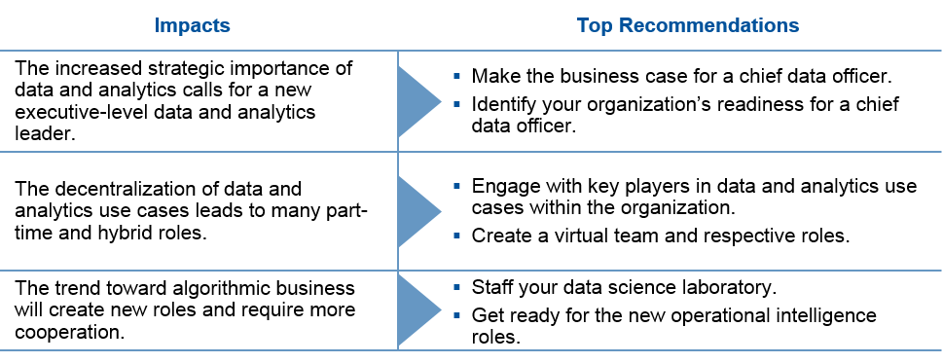

Source: Gartner (July 2016)

Impacts and Recommendations

The increased strategic importance of data and analytics calls for the creation of an executive-level data and analytics leader

A recent survey came to the conclusion that, "High performers attribute their data and analytics success to involved leaders, while low performers say their biggest challenge is designing the right organizational structure for analytics activities." [1](https://www.gartner.com/doc/3389917?srcId=1-6470977776#dv_1_the_need)

The rise of the digital business introduces a strategic issue for many companies. While everyone agrees on the importance of data and the increased use of analytics to reimagine decision making, many organizations do not yet have an executive who is responsible for the strategy and practice of data and analytics across the entire organization. The corporate strategy — and therewith the digital business strategy — is the responsibility of the executive team, yet the responsibility for crucial data assets and analytic applications is scattered across the organization. This disconnect carries the risk that competing priorities and a different focus prevent the organization from developing a comprehensive and cohesive vision and strategy that leverages data and analytics in line with the corporate strategy. Tackling this issue requires an executive role to mitigate the risks by building a corporatewide governance strategy and practice for data, analytics and algorithms.

*Recommendations:*

* Assess your organization's readiness for an executive-level data and analytics leader. Typical questions to ask include:
  + How is your business or industry likely to be affected by digital business in the next five years?
  + Is there already a digital business strategy or initiative in our organization?
  + Is there a common understanding and agreement that poor data quality causes real business issues and costs?
  + Is your organization struggling to develop a common data and analytics governance practice?
  + Do you see a lack of alignment between the corporate strategy and data assets, and analytics use cases?
  + Does your organization routinely overlook the need to measure the value of data and the success or impact of analytics on your business objectives?
* Reach out and communicate with business leaders across the organization. Discuss the issues they are facing with the current data and analytics practice, and explore new business opportunities (see Note 2).
* Make the business case for a CDO (see ["Business Case for the Chief Data Officer"](https://www.gartner.com/doc/code/254671?ref=ddisp)).
* Set the right expectations and identify the most important responsibilities for a CDO in your organization; for example:
  + Managing data as an asset
  + Improving data quality
  + The monetization of data
  + Developing an enterprise information management strategy
  + Developing a business analytics strategy
  + Developing an information governance strategy

The omnipresent decentralization of data and analytics use cases leads to many part-time and hybrid roles across lines of business, including IT, increasing business complexity

The reality today is that data and analytics use cases are spread across all different parts of an organization. This has increasingly led to turning traditional IT roles in data and analytics into hybrid roles, with the lines blurring between business and IT departments. For instance, the customer surveys for the Magic Quadrant for BI and analytics platforms for 2015 and 2016 revealed that, for about 42% of the approximately 2,000 responding clients, their role is a blend of IT and business. [2](https://www.gartner.com/doc/3389917?srcId=1-6470977776#dv_2_customer_survey),[3](https://www.gartner.com/doc/3389917?srcId=1-6470977776#dv_3_customer_survey)Only 33% indicated that their role is primarily IT, and 25% of the respondents reported having a primarily business role (see Figure 2).

**Figure 2.**Split of Roles

*Data from Gartner's customer survey for the BI and analytics Magic Quadrant, 2015; number of respondents = 2,028.*

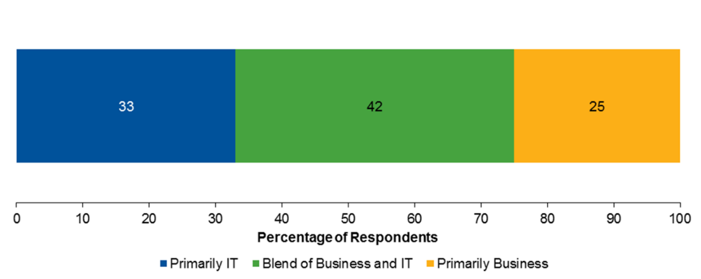

Source: Gartner (July 2016)

Gartner's customer survey for our Magic Quadrant for master data management of product data solutions for 2015, [4](https://www.gartner.com/doc/3389917?srcId=1-6470977776#dv_4_magic_quadrant)revealed a similar pattern. Information stewardship metrics — used to guide the performance measurement for information governance — were consumed by a wide range of both business (between 67% and 100%) and IT (11% to 80%) users.

Teams, functions or departments manage their own data assets for their specific needs, often siloed into many segments. Some will perform the analytics in addition (and often in isolation) to the reporting delivered by the central BI or analytics team. In other application silos, operational data will be so poorly and inconsistently governed that the budget is consumed in repeatedly cleaning up data, with IT having to maintain ever more complex data and application integration strategies. Even worse, the "you don't know what you don't know" issue arises, and too many silos lead to underutilized data assets.

Hybrid roles require a combination of IT and business skills; however, many data and analytics roles are not necessarily full-time jobs. Sometimes, they are an additional role that someone carries in addition to their main role. For instance, one of the business analysts may be the domain analytics leader, or the business process analyst and information steward may be combined into one role.

Many of the associates performing data and analytics tasks actually have a different job description; managing data or performing analytics is a role they carry out in addition to their main function. The data and analytics role they carry becomes a part-time role — such as citizen data stewards or citizen data scientists. Often, these associates are unknown to the central data and analytics teams, working in isolation until a problem occurs and they have to reach out to the central teams for support.

*Recommendations:*

* Engage with the key players of data and analytics use cases across your organization. Identify who is involved in managing data and analytics use cases. Consider these main roles in decentralized deployments, which need to be identified:
  + Domain data and analytics leaders within the departments, functions and teams.
  + Business analysts, who develop the descriptive and diagnostic analytics for their respective teams.
  + Business process analysts, who support the use of information in, across and between business applications, and are focused on decision management, data quality and master data management.
  + Information stewards (for example, business users), who focus on the operational side of information governance.
  + Data scientists.
* Create a virtual cross-organizational team, where you can outline the data and analytics use cases and the respective key players and their roles. This is the foundation from which to collaboratively develop and execute your data and analytics strategy and governance model. This virtual team will be the basis for:
  + Balancing agility requirements in the various parts of the business, while avoiding having too many data assets and analytics use cases operate in silos.
  + Communication and collaboration as the key to developing a successful data and analytics practice — despite this being distributed across the organization.
* Develop a training program to support the hybrid roles necessary to develop the right combination of skills:
  + Identify the business or subject matter expertise, analytical skills and technical skills that are required, and build a modular training program.
  + Use this combination of skills during your recruiting process for new resources, to identify the right candidates (and their potential development plans) to fit within the new roles.
  + Establish a career progression path for these roles.
* Establish a communication platform, including, for instance, a data dictionary and a business glossary, or leverage information stewardship applications (see ["Market Guide for Information Stewardship Applications"](https://www.gartner.com/doc/code/292358?ref=ddisp)).
  + Use this as the central platform for communicating with and understanding the problems of the associates involved in the decentralized data and analytics use cases.
  + Leverage this platform as a learning platform and an opportunity to share best practices.

The trend toward algorithmic business will create new responsibilities and roles for those managing data and analytics

There are great expectations that the algorithmic business will fuel the digital business and that it offers great opportunities to create differentiation and innovation. However, developing the algorithms and embedding them into business processes requires the right staff and roles. Traditionally, analytics, applications, and operational and analytical data management have been distinct tasks performed by dedicated teams, often in different departments. However, the nature of the algorithmic business is such that the algorithms now become part of the business process.

For instance, recommendation engines, dynamic pricing, location-based advertising and predictive maintenance typically leverage predictive and prescriptive analytics, which need to be integrated with the overall process management and applications. In addition, if these algorithms operate in real time or near real time, new technologies — and therewith new skills — will be required: for instance, rule engines, business activity monitoring, stream analytics (complex-event processing) or other operational intelligence tools. The roles involved in designing and building continuous operational intelligence into business processes and business operations (see Figure 3) require that business analysts, analytics professionals and software developers acquire new skills and perform new functions — which span the analytics, application development and information management departments.

There is, as yet, no formal education for these new roles, so organizations need to be creative and flexible in building the necessary skills and competencies required. Candidates for the new roles are likely to come from different parts of the business and need to expand their expertise beyond their core competencies.

**Figure 3.**Continuous Operational Intelligence

*Op Int. = operational intelligence.*

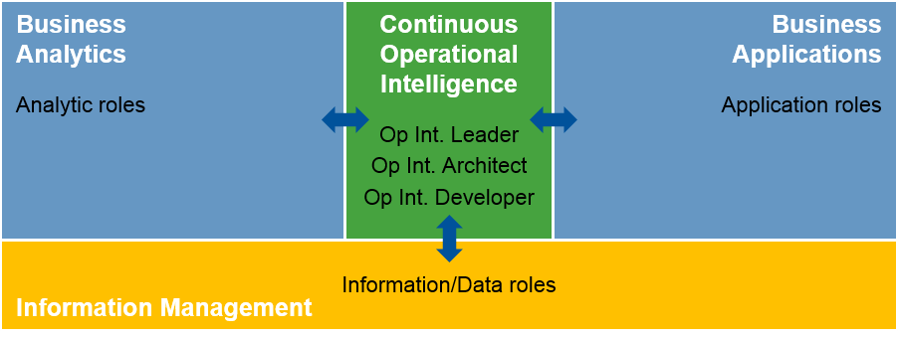

Source: Gartner (July 2016)

*Recommendations:*

* Build and staff the data science laboratory to develop new algorithms. You need to establish and fill roles such as data analysts, data scientists, statisticians, developers and data engineers (see ["Staffing Data Science Teams"](https://www.gartner.com/doc/code/270087?ref=ddisp)). The key role of the data science laboratory is to provide the "sandbox" environment in which to experiment with and develop the algorithms for the business.
* Get ready for new operational intelligence roles to form a bridge between analytics, applications and information management and to focus on the reimagined business decision. As you start to use more algorithms or new data sources, consider preparing for and identifying candidates for the following three roles, be they part-time or full-time:
  + Operational intelligence leader; candidates can be the:
    - Data and analytics leader
    - Business transformation leader
    - Business process management leader
    - Enterprise architect
    - Process optimization leader
  + Operational intelligence architect and operational intelligence developer, who drive:
    - Analytics and application integration
    - Process optimization
    - Process improvement
    - Business transformation
    - Situational awareness
  + Develop a training program to make sure the new operational intelligence roles understand:
    - Business processes management
    - Technologies, such as decision modeling, stream analytics (complex-event processing), business activity monitoring (BAM) and intelligent business process management systems (iBPMS)
    - Process mining and process discovery
    - Building predictive and prescriptive analytics
    - Business rule management
    - Application development and application integration
* Treat the path toward establishing your new operational intelligence roles as an opportunity for learning and growth. Ensure collaboration and sharing about lessons learned and best practices.